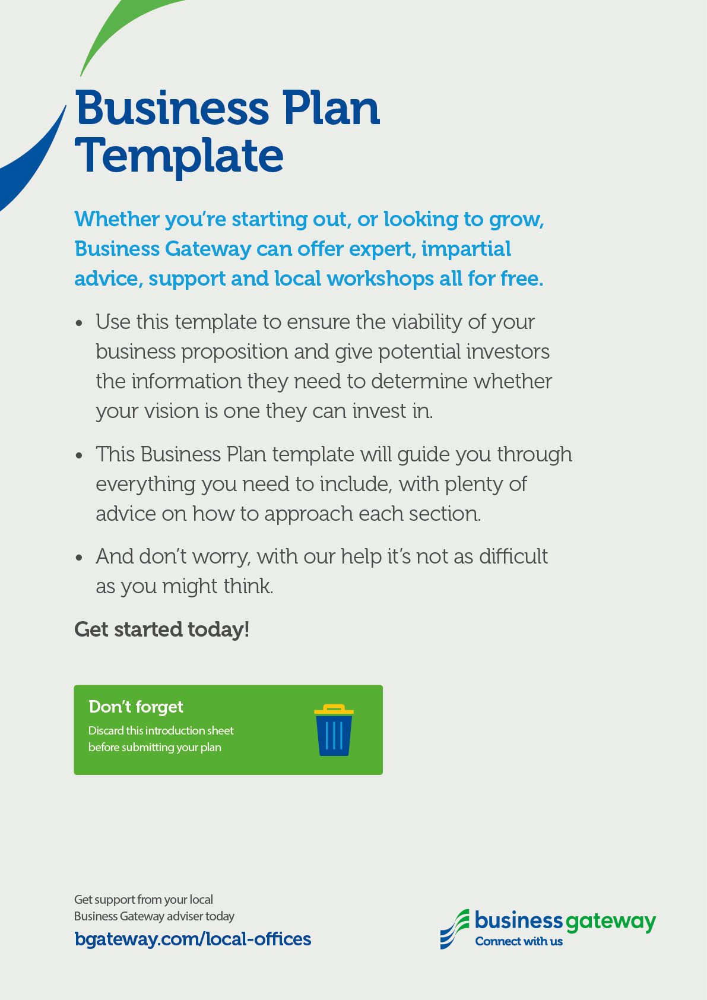

Name:
Business Plan for:

(Please use this template in conjunction with the guide Prepare a business plan)
Document Version:
Date:
Completed by:

Business plan contents
Executive Summary 1
1. Executive summary 1
2. Business details 2
Key personnel 3
Vision 4
3. Business Overview 4
4a. Business goals 4
4b. What the business does 5
4c. What makes the business different 5
4e. Legal requirements 6
Marketing 7
5. Market research 7
6. Market Overview 7
7. Competitor analysis 8
8. Sales 9
9. Marketing 9
10. Pricing 10
Running the business 11
11. Staff 11
12. Premises 11
13. Suppliers 11
14. Equipment 12
15. Managing operational risks 12
Finance 13
16. Finance 13
17. Profit and loss forecast 15
18. Sourcing finance 16
19. Cash flow forecast 17

Executive Summary

1. Executive summary
(We suggest you complete this section after you have completed the other sections of the Business Plan).

2. Business details

Company name:

Address:

Telephone number:

Legal status:

Advisors:

Are you / will you be VAT registered:

Do you have an online presence:

The business will: (Provide a brief description of what your business will do)

Key personnel

Details of owner(s):
Name:
Position/main responsibilities:
Experience and knowledge of our industry:
Previous employment:
Key skills brought to the business:
Business experience and any training undertaken:
Academic/professional qualifications:
Most recent salary £

Other key personnel (including shareholders):
Name:
Position/main responsibilities:
Experience and knowledge of our industry:
Previous employment:
Key skills brought to the business:
Business experience and any training undertaken:
Academic/professional qualifications:
Most recent salary £

Vision

3. Business Overview

Sum up your business idea:

4a. Business goals

What do you want to achieve in your first year of business? (for example, turnover of £100,000 or trading at breakeven)

Where do you see your business in 3-5 years’ time?

4b. What the business does
Product/service | Features | Benefits

4c. What makes the business different

Your product/service is unique or different compared with the competition because:

4d. SWOT analysis

What are the key strengths of your business:

What are the key weaknesses of your business:

What are the opportunities:

What are the threats your business faces:

4e. Legal requirements
(including regulations and licences particular to your business)

The legal and insurance requirements that apply in your business are:

You will meet your legal and insurance requirements by:

Marketing

5. Market research

Trends in your chosen market are:

How you know this:

6. Market Overview

The customer groups you will be selling to are and what is the market size are:

Your customer research has shown what your customers want is:

How you know this:

How many customers / clients do you require and what will you sell them

7. Competitor analysis
Competitor name | Strengths | Weaknesses

What information have you gathered on your competitors

How you can improve on their offer and/or price(s):

Competitive advantage:

8. Sales

9. Marketing

How and where will you promote your product/service?

10. Pricing

How you can calculate your prices:

How your prices compare with the competition:
Product/service | Your price(s) | Range of competitor prices (per unit)
 | £ | £
 | £ | £
 | £ | £
 | £ | £
 | £ | £
 | £ | £
 | £ | £

Reasons for the difference between your price(s) and your competitors’ price(s):

Running the business

11. Staff
Role | Total cost | Necessary experience | Specialist skills and/or qualifications
 | £
 | £
 | £
 | £
 | £

12. Premises
 | Cost £
Premises required at start-up: | £
Premises required in the future (if different): | £

13. Suppliers

Your key suppliers and their credit terms
Supplier | What you’ll buy from them | Number of days’ credit

14. Equipment
Resource | When | How funded | Cost £ per unit
 |  |  | £
 |  |  | £
 |  |  | £
 |  |  | £
 |  |  | £
 |  |  | £
 |  |  | £
 |  |  | £
 |  |  | £

15. Managing operational risks

Risk | Solution
Staff

Suppliers

Financial

Marketing

Finance
(The financial section of the template is intended for business planning purposes only. If financial tables are to be used for any other purpose other than cash flow management, then we strongly recommend you consult an accountant or tax advisor)
Please double click in the table below to access the embedded Microsoft Excel sheets to input your figures, Microsoft Excel will automatically update the total for you. If you do not have access to Microsoft Excel you can use the link below this table and save the file onto your PC. You can then use Open Source Software such as Google Docs or OpenOffice to access the information by uploading the file into this software. Please note that all tables can be customised and additional rows and categories can be added.

16. Finance

Calculate how much money you need before you start trading
 | £
IT and computers | 0.00
Telephones and broadband | 0.00
Equipment | 0.00
Stock | 0.00
Tools | 0.00
Vehicles | 0.00
Professional fees | 0.00
Insurance | 0.00
Rent/rent deposit | 0.00
Stationery | 0.00
Marketing | 0.00
Consumables | 0.00
Licences | 0.00
Training | 0.00
Association fees | 0.00
Wages/recruitment | 0.00
Security/health and safety equipment | 0.00
Market research costs | 0.00
Other (please specify) | 0.00
 | 0.00
 | 0.00
 | 0.00
 | 0.00
 | 0.00
TOTAL £ | 0.00

* Total from here should be used in 22 Sourcing finance below
You can also download the start up costs table shown above in Microsoft Excel format.

Personal survival budget

Estimated annual personal expenditure (this helps you work out the minimum amount you need to earn from your business in the first year and how much money you might need to borrow to start the business)
Estimated expenditure | £
Mortgage and/or rent | 0
Council tax | 0
Utilities (gas, electricity, water etc) | 0
Personal and property insurance | 0
General housekeeping expenses (food etc) | 0
Phone and internet | 0
Car tax and insurance | 0
Car running expenses | 0
HP repayments | 0
Hire charges | 0
Subscriptions to journals, professional bodies, etc | 0
Savings plans & pension contributions | 0
Contingencies | 0
Tax | 0
National Insurance | 0
Other: please specify | 0
 | 0
Total personal expenditure | 0
Estimated personal income (after tax)
Income from family, partner (total) | 0
Other income (specify the source) | 0
Total personal income | 0
Total survival income required from the business (after tax) | 0
Current income | £ 0

You can also download the personal survival budget table shown above in Microsoft Excel format.

17. Profit and loss forecast
 | Year 1 (£) | Year 2 (£) | Year 3 (£)
Total expected sales | 0 | 0 | 0
Less variable costs | 0 | 0 | 0
Gross profit (sales less variable costs) = | 0 | 0 | 0
Calculate your gross profit margin % (gross profit divided by total sales x 100) (A) | 0 | 0 | 0
Salaries/wages (survival income + any staff) | 0 | 0 | 0
Premises (including rent, rates, utilities) | 0 | 0 | 0
Telephone and broadband | 0 | 0 | 0
Printing, post and stationery | 0 | 0 | 0
Advertising and promotion | 0 | 0 | 0
Bank charges | 0 | 0 | 0
Professional fees | 0 | 0 | 0
Insurances | 0 | 0 | 0
Bank/HP/Interest (payable to your bank) | 0 | 0 | 0
Stock | 0 | 0 | 0
Consumables | 0 | 0 | 0
Equipment and vehicle leasing | 0 | 0 | 0
Depreciation | 0 | 0 | 0
Other (please specify) | 0 | 0 | 0
Other | 0 | 0 | 0
Other | 0 | 0 | 0
Total fixed costs | 0 | 0 | 0
Net profit (gross profit less fixed cost) | 0 | 0 | 0
Calculate your net profit margin (net profit divided by total sales x 100) | 0 | 0 | 0
Calculate your breakeven | Year 1 (£) | Year 2 (£) | Year 3 (£)
Total variable costs + total fixed costs (B) | 0 | 0 | 0

You can also download the profit and loss forecast table shown above in Microsoft Excel format.

18. Sourcing finance

Total borrowing requirement for the business

 |  |  |  | £
Start-up costs |  |  |  | 0
Personal start-up contributions |  | - |  | 0
Other start-up contributions |  | - |  | 0
Total required |  | = |  | 0
 | The assets you have available as security
 |  | = |  | 0

You can also download the sourcing finance table shown above in Microsoft Excel format.

19. Cash flow forecast
See Excel file that accompanies this Business Plan
