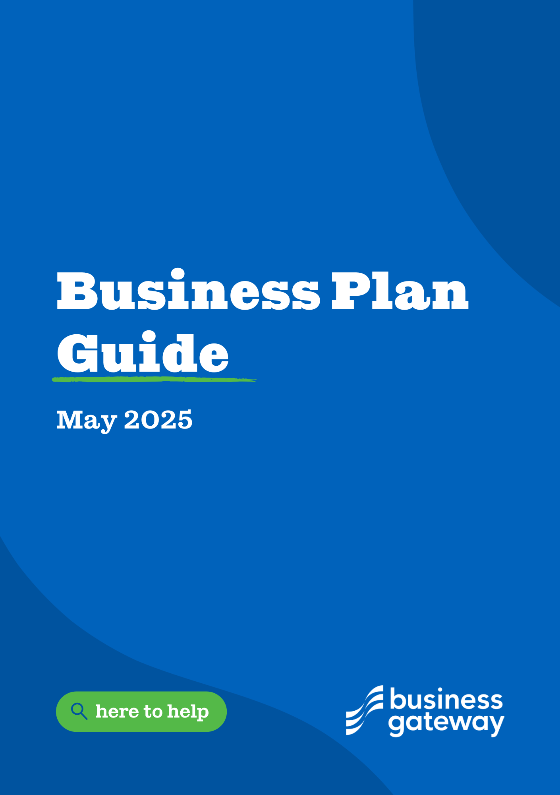

Your guide to writing a business plan

**Whether you’re starting up or have already begun, a business plan is an essential tool. It keeps you on the right track. And, if used properly, it prevents unpleasant surprises, enables you to be flexible and helps you adapt to changing circumstances.**

We understand that compiling a business plan can be quite daunting. That’s why Business Gateway has developed a template. Using the template is an easy and efficient way to focus on your business and get organised.

This guide helps you complete the template. It sets out the different sections a business plan should cover, including financial forecasts.

By using this guide to answer the template questions, you’re steered through the whole process, saving you time, effort, and worry. Working this way, you get a comprehensive plan, ready for use. You can of course add appendices to give more details, for example, on research, evidence, analysis and other matters.

**Contents:**

1. Executive summary 4

2. Business Details 4

3. Business Overview 5

4. Business Goals 6

5. Market Research 8

6. Market Overview 8

7. Competitor Analysis 9

8. Sales 10

9. Marketing 10

10. Pricing 11

11. Staff 11

12. Premises 12

13. Suppliers 12

14. Equipment 12

15. Managing operational risks 13

16. Fair Work 13

17. Sustainability 14

18. Finance 15

1. Executive summary

It’s a summary. So, writing this section of the document usually comes last, after you’ve completed the other sections. When you complete the other sections, you’ll find it straightforward and quicker to write this section.

In this summary you **reiterate the highlights of sections 2-29.**

You should also explain the purpose of the plan.

For example, whether the document is intended for seeking funding from lenders and investors or looking for new partners. It could of course also be a strategic internal document.

2. Business Details

In this section you set out the details of your business.

**Include your business name**. If it has a different trading name, include them both.

**Your business address goes in here**. For example, does it operate from a home, office, retail unit or manufacturing space? Or is it a mobile business or something different?

Enter your own contact details.

**Mention the legal structure of your business.** For example: Sole Trader, Partnership, Limited Company, Limited Liability Partnership, Social Enterprise, or Community Interest Company.

Insert the **date your business was or will be established**.

If you’ve registered your business, you may be liable for corporation tax, so mention the registration date.

Your Business Registration Number goes in here. If you’re not registered, just put ‘Not Applicable’.

**Advisers,** you should list your advisers, your accountant, bank manager, independent financial advisers, lawyer, surveyor, mentor. Show that you have discussed your business idea with a range of individuals with different experiences.

You can also outsource business functions. For example, book-keeping or secretarial work.

Advisers and support services:

* List the names of you advisers and support service suppliers.
* Describe the advice, services or support they supply.
* Mention their contact details.

**Have you registered for VAT?** If so, mention the date when you did so and then your VAT number. If not, put in

‘Not Applicable’.

**Do you have an online presence?** For example, a website, X handle, TikTok, Facebook page or Instagram account. Mention them all here.

**Key personnel**, add in who your main personnel are. It may just be you or one other. List what their last role was, what their experiences are and what was their last salary.

3. Business Overview

If you’re a start-up, this is where you **explain your idea**, and what your proposed products or services are.

If you’re an existing business, **explain what the business does**.

It may be useful to include a bit of background. For example, how you got to this position. Did you buy the business or are you the original owner? And do you own intellectual property, such as a patent or trademark?

In either case, explain **why the business should or does exist,** other than simply to generate profit for you.

4. Business Goals

**Business Goals**

Describe what you want to achieve in the coming year. This can be a financial or a non-financial goal.

If you’re a start-up, you may simply want to break-even by a particular date, make a specific amount of profit, get a set number of clients, or have your product stocked in particular stores.

If you’re already trading, you may want to break into another geographical market, launch new products or services or increase (or decrease) your workforce.

In either case, try to be precise. Use **SMART objectives** – specific, measurable, achievable, and realistic. Then you can tell when you have reached them. Or they give you a benchmark, so that you know what to change or improve in order to achieve it.

After that, **describe where you see your business in 3-5 years’ time**. These longer-term objectives don’t need to be so precise. However, the more precise, the easier they are to plan for.

**What the business does**

What products, services and features and benefits will you supply.

List the main aspects of them into the table.

An example: Product – Bread, Features – Range of white, brown, seeded, - Benefits – Made fresh every morning.

**What makes the business different?**

List what makes your product/service unique or different compared with competition. Why will people buy your product?

**SWOT analysis**

A SWOT analysis is a good way to reveal insights and flag up risks, whether you’re starting or growing the business. It also helps in the future when you’re assessing your situation and must change your plan.

Strengths and weaknesses are internal – about your business. Opportunities and threats are external – factors that affect your business.

Complete each of the following statements:

1. What are the key strengths of your business?

Describe your strengths. For example, you have a superior quality of product, specialist team, wide range of services, industry knowledge, innovation or that you know the local area.

1. What are the key weaknesses of your business?

Mention your weaknesses. For example, a lack of finance or staff, dependency on one supplier or reliance on one main customer.

You may not be an expert is sales, or bookkeeping, if not what will you do about it to rectify that expertise?

1. What are the opportunities?

List the opportunities. For example, an increasing market for your product, clear gap in the market, new technology or business partnership.

1. What are the threats your business faces?

Don’t forget threats. For example, you could face increased competition, an economic downturn, or a change in legislation, which will make trading more difficult for you.

**Legal requirements**

(Including regulations and licences particular to your business)

List all licensees, insurances, and legal requirements you will need to consider, identify, apply for, and gain to allow you to start your business?

You should be thinking of employer insurance, public liability insurance, environmental health review, building warrants, or planning permissions.

5. Market Research

**Market research**

Say what kind of customers you’re targeting. For example, consumers, businesses, or organisations.

When you’re aiming for consumers, demographics, type, where they live, what they work at.

When aiming for businesses or organisations, mention the size of their business.

Describe the key characteristics of your customers.

List what they care about most when it comes to your product or service. For example, what influences their buying habits – price, quality, speed of delivery, environmental issues, or ethical concerns.

**What are their reasons for buying from you?** For example, why they wouldn’t buy the same product or service from somewhere else.

You can get this type of information from a variety of sources. For example, marketing questionnaires, surveys, focus group reports, online research, social media, testimonials from customers and personal experience.

If you target different customer groups or segments, you may have to give several target profiles.  
  
Visit <https://www.bgateway.com/our-services/research-service> for more information on ways Business Gateway could help if you need support with market research.

6. Market Overview

This section **shows how much you know about the market in which you operate.** Try to be precise and use your experience or research to complete this section. Please visit [bgateway.com/your-sector](https://www.bgateway.com/your-sector) for more information about each market.

You need to gain a greater understanding of your customer market, who they are, where they live, what they do, are they business or residential consumers.

Just as in the target market, many sources provide market data. You can also visit trade fairs or conduct mystery shopping to get more information.

Describe the size of the market. What is the market outlook – do you see it growing in years to come? What are the key features and are there any specific trends?

Examples:

If you are a manufacturer state how many “widgets” you will produce each day and how much you will sell them for.

If you are a newsagent, you may state that you will have 100 customers per day 50% will purchase a Newspaper, 30% will purchases sweets, 20% will purchase books.

7. Competitor Analysis

In this section, look at **outlining the main competition**. Who are your main competitors? What are their products and prices? You should gather up-to-date information on at least three competitors. That may take some time if you haven’t already done so. For this purpose, you can study competitor websites. You can also buy and try out their products.

You might want to consider the following:

List at least three competitors, and then list what their strengths are and what their weaknesses are.

* What products or services do they sell?
* What do you see as the strengths of their business?
* What are their weaknesses?
* What prices do they charge?
* If you know, mention their market share or position.
* If they have one, describe their reputation.

Competitive advantage

This section shows you’re clear about why you feel your business can survive profitably in a competitive market.

* What do you see as a gap in the existing market?
* How do you differ from the competition?
* What is your unique selling point? Any points of difference?
* What proof do you have to make each claim? If you don’t have any supporting evidence, then you won’t be able to claim it and will need to find something else to justify your competitive advantage.

8. Sales

Describe **how you sell your product or service**. For example, on the internet, via social media, through a retail outlet, or all. Also highlight whether you’re selling to individuals or organisations.

Or if you’re using or planning to use an agent.

This should be a general description. Later in the form, you must calculate the costs involved in selling, including management time or commission fees.

9. Marketing

This section shows how you promote your business.

You should say how you inform customers and persuade them to buy your product or service. For example, through social media, advertising, direct mail, exhibitions and conferences, websites, and PR.

Promotion costs are measured in money and time.

This should include a section on how they will market their business if they are a shop, i.e., do they need window decals, menus, business cards.

Will they need a van, and do they plan to have the van have their business name and logo on it?

Think about workwear with company logos on it.

|  |  |  |  |  |
| --- | --- | --- | --- | --- |
| Method | Detail | Success will be measured by | Competitor using method? | Costs |
| Print advert in | ½ page ad | Number of | No | £250 |
| local free |  | people phoning |  |  |
| community |  | up for more |  |  |
| newspaper |  | information |  |  |
| Advert in | Display ad | Number of | Yes | 1 hour taking |
| Gumtree |  | people phoning |  | photos and writing |
|  |  | and booking |  | and posting the ad |
|  |  | services |  | (Calculate the cost |
|  |  |  |  | of one hour of your time) |

10. Pricing

You need to consider what price you will charge per product or service and how that compares to competitor pricing.

The business should also be ensuring at this time that they are making profit on each item they sell. The business should work out what is the Cost of Production / Cost to Purchase, and ensure the margin covers these direct costs, but also indirect costs such as overheads, wages etc.

Once you have reviewed the pricing, then list any reasons for the difference between your price(s) and your competitors’ price(s): this could include you are buying at a lower cost, you have lower overheads.

This article might help if you’re unsure of what costs to consider: <https://www.bgateway.com/resources/8-tips-on-identifying-the-main-costs-when-starting-a-business>

11. Staff

In this section you **mention the key people in your business**. It may only be you, but you could also have a management team, in which case you should give profiles of all managers.

Management team:

* List the names of your management team. Mention their responsibility in your business. For example, in production, sales, marketing, finance or administration.
* Who do they report to?
* Do they have experience relevant to the business?
* What will they cost / what is their salary, company national insurance, pension.
* Do they bring investment to the business?
* What key skills do they bring to the business?

You may want to have somebody who would be in charge should anything happen that prevents you from fulfilling your own role.

Here you should state how many employees you have or need,

If you have one enter in an organisation chart.

Say whether they have or need any special skills. Are there minimum national standards/ employment regulations which you need to bear in mind?

12. Premises

Describe in detail **what premises you have or are looking for**. For example, a home, rented or bought property. If there’s a lease involved, mention the length of lease. List all the related costs. For example, rent, mortgage, gas, electricity, telephone, or furniture purchases.

It’s also useful to state whether you’ll be considering changes in the future.

What are the advantages / disadvantages of your current location, if the business is to grow, change or move?

13. Suppliers

This section **lists your main suppliers** (you can add more rows to the table as needed). A good relationship with suppliers is essential for success, as it should mean timely delivery, good quality and efficient cash flow.

* Give the names of the suppliers.
* What products or services do they supply?
* What is the number of days credit they offer?
* Describe your reasons for choosing them.
* Are there any risks?
* Do you have a tendering process?

14. Equipment

This section shows what resources you have or need in terms of equipment and machinery.

* What is the resource you need?
* Do you already own it?
* What’s the current value? There are separate boxes to say what the value is if the resource is bought, updated or replaced.
* When do you need the resource?

List all the resources you require.

Think both about the starting of the business and the initial equipment and about what equipment you will need in the first few months.

Consider when you will purchase it, how much it will cost and how you will fund it; own cash, loan, hire purchase.

15. Managing operational risks

This section lists all possible risks to the business that would prevent you from trading. For example, disappointing sales, planned investment falling through, inability to recruit staff, IT systems failure, competitors’ actions, sudden changes in compliance law or environmental hazards. It may be useful to include who can take charge of the business if you, for whatever reason, would be unable to fulfil your role.

Mention the risks you foresee?

How are you going to manage these risks?

Mention possible cost implications?

Think of risks that you may have these could include staff, supplies, cash.

Then consider how would you manage such risks and how would you put plans in place to mitigate them. i.e., what solution will you have to resolve that risk.

16. Fair Work

The Scottish Government has a vision for Scotland to be a leading Fair Work Nation, where high quality and fair work is the norm in workplaces across Scotland. They are moving towards a more formal recognition of Fair Working Practices:

<https://www.gov.scot/publications/fair-work-first-guidance/>

Fair Work First is the Scottish Government's flagship policy for driving high quality and fair work across the labour market in Scotland by applying fair work criteria to grants, other funding and contracts being awarded by and across the public sector, where it is relevant to do so. Through this approach the Scottish Government is asking employers to adopt fair working practices, specifically:

* appropriate channels for effective voice, such as trade union recognition;
* investment in workforce development;
* no inappropriate use of zero hours contracts;
* action to tackle the gender pay gap and create a more diverse and inclusive workplace;
* payment of the real Living Wage;
* offer flexible and family friendly working practices for all workers from day one of employment; and
* oppose the use of fire and rehire practice.

In this section, describe how you will commit to fair work practices for workers (including any agency or sub-contractor workers) engaged in the delivery of your services or products.

17. Sustainability

Adopting sustainable practices will help:

* Make your business more attractive to customers and staff
* reduce costs
* protect your business from risk

In this section, you should document your environmental policy. This should include:

* The business mission and information about its operations.
* A commitment to continually improve your environmental performance.
* A commitment to effectively manage your significant environmental impacts.
* The expectations that your business has in relation to external parties such as suppliers and contractors.
* Recognition that you will comply with relevant environmental legislation as a minimum level of performance.
* Education and training of employees in environmental issues and the environmental effects of their activities.
* Monitoring progress and reviewing environmental performance against targets and objectives on a regular basis
* A commitment to communicate your business' environmental aims and objectives to all staff, as well as to customers, investors and other external stakeholders.

18. Finance

Alongside the embedded excel template that can be used to calculate your forecasts, this section provides an overview of the costs and overheads you need to consider running the business on a day-to-day basis.

1. **Finance**

This section lists the costs to produce and deliver your products or services, and the price at which you sell them.

Include overhead items such as rent costs, utility bills, wages, and national insurance contributions. You also need to include your time that is or will be invested in production and delivery.

If you already know your hourly rate, then a basic formula for calculating costs is hourly rate x hours.

If you’re already in business, this may be a time to adjust. For example, with new suppliers, amended credit terms, more efficient equipment, or reduced overheads.

1. **Personal survival budget**

Following on from the overhead costs is a section which enables you to work out what income you have coming in and what income you need to survive. This will provide an indication of how much you need to make from your business to meet your household and personal expenditure.

1. **Profit and loss forecast**

In this section you give a statement on the trading position of your business. It’s a requirement of any business plan.

It shows the profit you expect to make, the costs of providing goods and services, and your overheads.

You may have to make assumptions. If you do that, you should note it in your plan. It’s useful to provide a range of forecasts.

For example, three forecasts, including expected, pessimistic, and optimistic sales figures.

This is where you should use the table provided to calculate what your sales will be, what your cost of sales will be and what your overheads will be. This will then enable you to calculate your profit or loss.

1. **Sourcing Finance**

How will you fund your plans, where will that funding come from?

* Personal funds
* Family and friends
* Grants
* Loan

If it is a loan, make sure you include the repayments and interest within the cash flows and profit and loss.

1. **Cash flow forecast**

Financial forecasts are an essential part of a business plan, whether you’re starting out or already in business. However, forecasts are only successful when they’re thorough and realistic.

In this section you forecast when money comes in and goes out of your business. Getting this right helps you ensure that there’s always enough cash to pay expenses when they are due, and to avoid having to raise extra money or cease trading.

|  |
| --- |
| For more information visit [**www.bgateway.com**](http://www.bgateway.com/)  or contact your local Business Gateway office for further guidance on the next steps and further support on developing your business. |
|  |
| To download the template visit [**www.bgateway.com/businessplan**](http://www.bgateway.com/businessplan) |