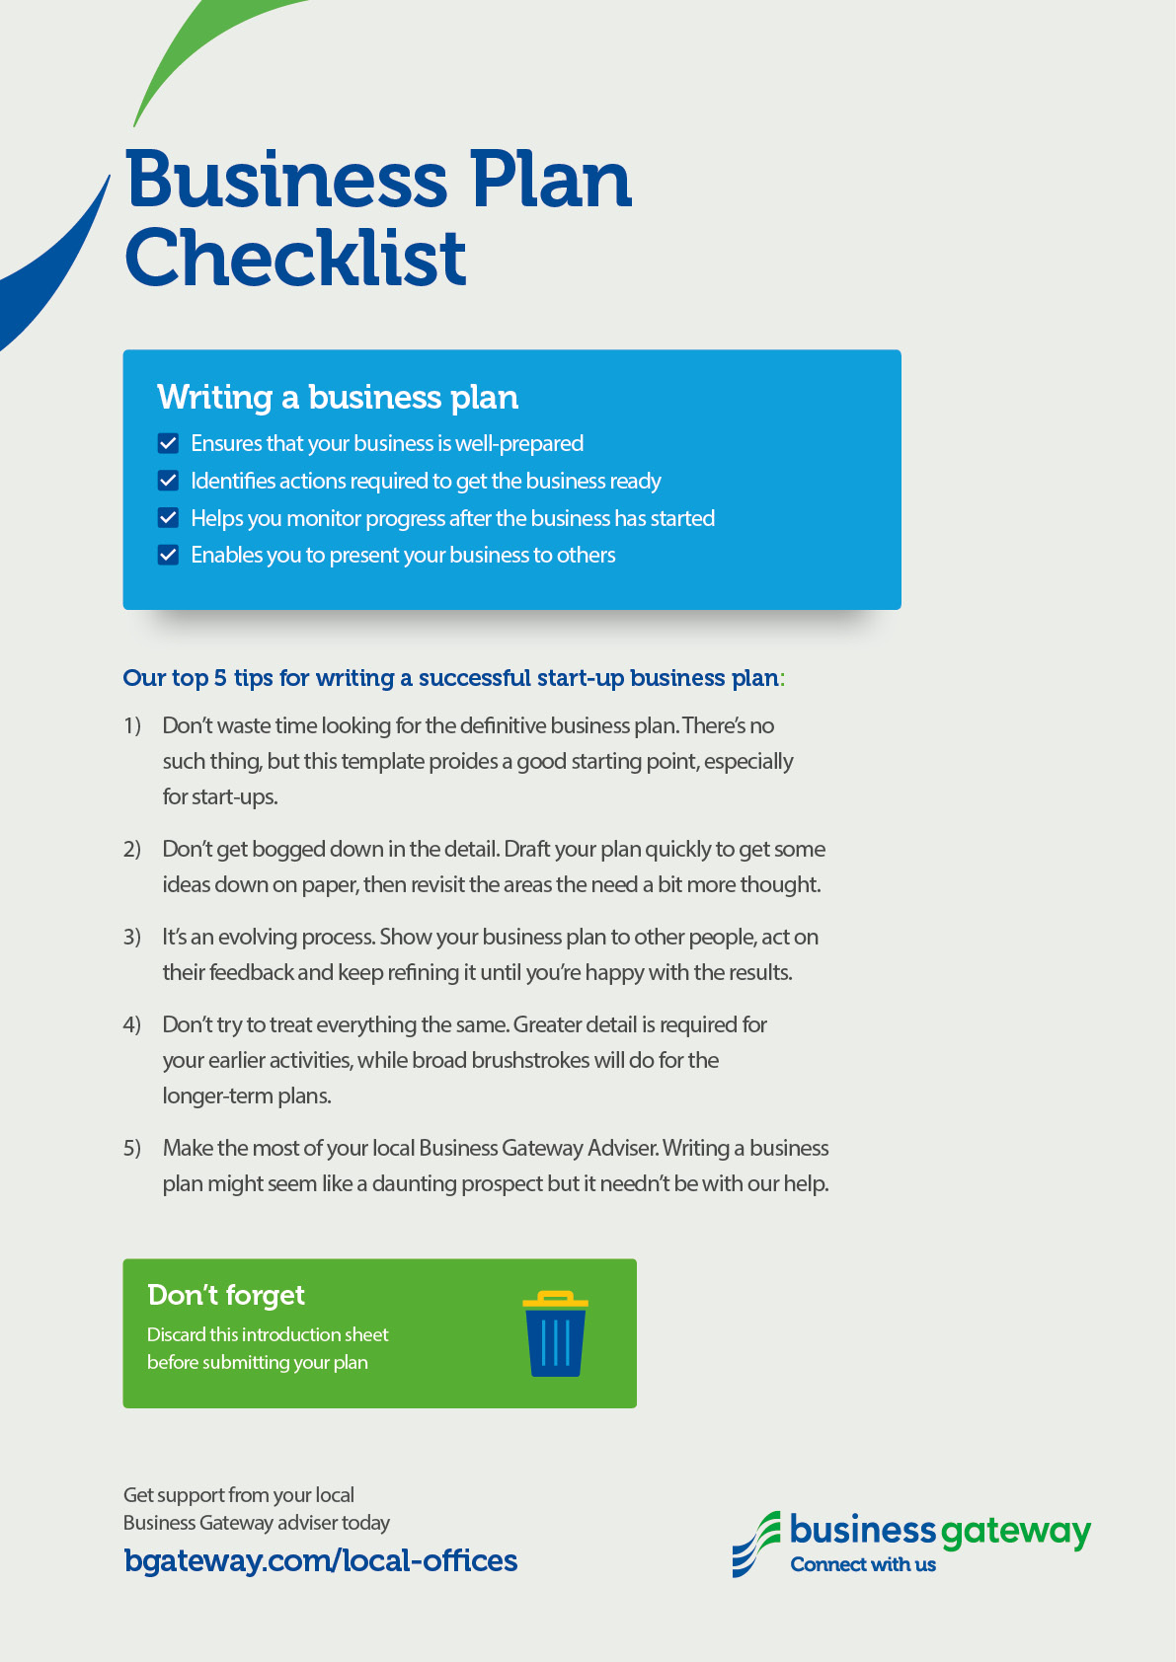

CONTACT INFORMATION
Business name:
Business activities:
What the business does.
Start date:
Business owner:
Business/home addresses:
Legal structure of business:
Eg sole trader, partnership, ltd company.
Phone numbers:
Email address:
Website:
Bank:
Accountant:
Solicitor:

BUSINESS OVERVIEW
An Executive Summary of the whole business plan – best completed at end.
BUSINESS ACTIVITY

Products & Services
What products/services you’ll provide and how they’re different from your competitors (eg price, quality, availability, customer service, guarantees).
Pricing
How you’ll set your selling price (based on eg hourly rate, mark-up on materials, discounts) and when customers will pay (eg deposits, credit).

MARKETPLACE
Customers
What type of customers you’ll target (eg general public, business), their characteristics (eg age, gender, size of business) and location (eg local community, central Scotland, worldwide).
Competitors
Who they are and their respective strengths/weaknesses.
Suppliers
Who’ll supply you with what (eg materials, stock, services) and when you’ll pay them (eg cash with order, credit).
Research
What are the key market trends and their associated opportunities/threats for your business.

RESOURCES
People
Your key people’s experience and qualifications, their roles and how much time they’ll spend on activities (eg selling, preparing quotes, delivering services, book-keeping), plus details of any back-up in case of ill health.
Premises
Where you’ll be based (home, business premises), your rent and rates, any repairs/refurbishment required, lease conditions and length, and planning permission.
Tools & Equipment
What equipment you already own and what you’ll need to purchase/lease.
Stock
What initial stock you’ll need, how much it’ll cost and where you’ll keep it.

Advertising & Promotion
How potential customers will get to know about your business (eg adverts, directories, word of mouth, referrals from other businesses, mail shots, website, business cards, brochures, flyers).
Insurance
What insurance you’ll have (buildings and contents, public liability, employer’s liability, product liability).
Legal Issues
What licences are required, trademark/patent/copyright matters, data protection, and health & safety.
Funding Summary
Your main items of expenditure and how you’ll fund them (cash, loans, grants).

FINANCIAL FORECASTS
Estimate the sources and timing of money into the business, and what you’ll use it for.

